**Lesson 8 Demo 1**

**Creating Ansible Roles to Copy Files**

**Objective:** To create and work with Ansible Roles

**Prerequisites:** You need to have Ansible installed to proceed with this demo. If you don’t have it installed, refer to demo 1 of lesson 2.

**Tools required:** Ubuntu terminal, Ansible

**Steps to be performed:**

1. Establishing connectivity between Ansible controller and node machine
2. Creating Ansible Role
3. Creating Ansible tasks
4. Creating Ansible template
5. Creating Ansible variable
6. Removing unwanted directory
7. Creating Ansible role playbook
8. Installing sshpass
9. Deploying Ansible role playbook

**Step 1: Establishing connectivity between Ansible controller and node machine**

1. Once you have Ansible installed, establish an SSH key pair in the Linux system to establish SSH connectivity with the localhost using the following commands:

***ssh-keygen -t rsa***

***cat .ssh/id_rsa.pub >> .ssh/authorized_keys***

***ssh localhost -p 22***

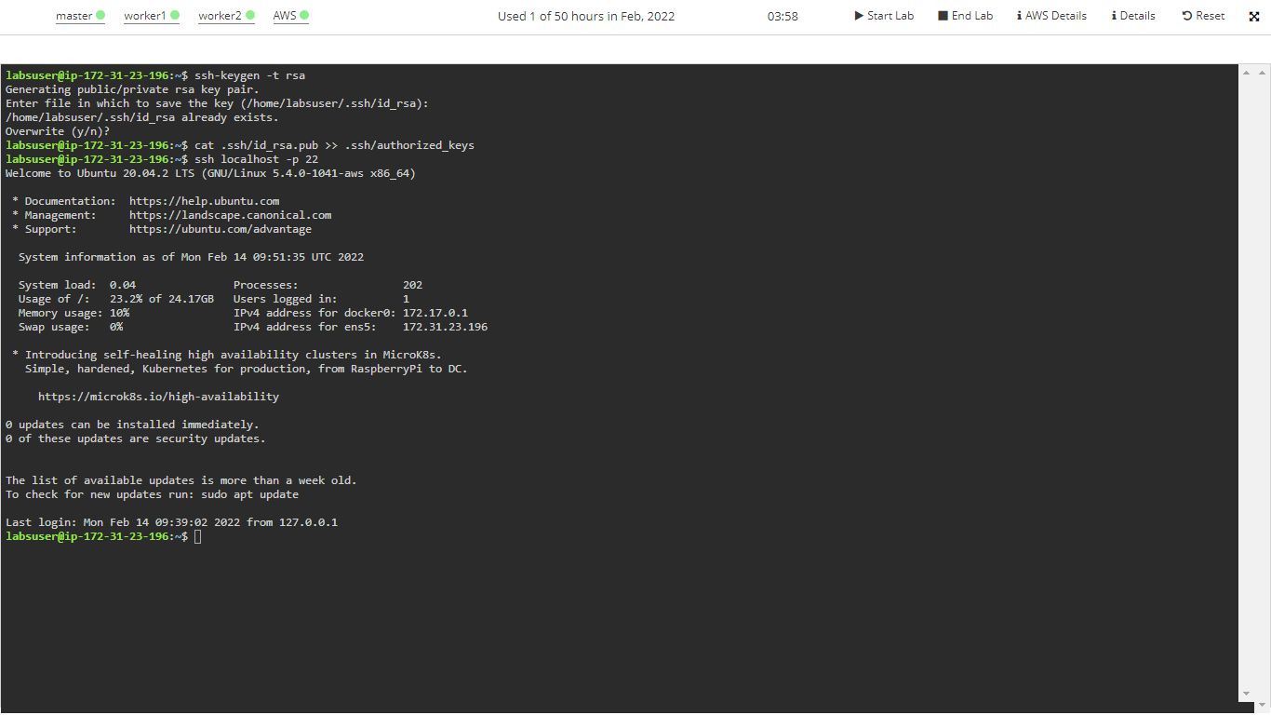

1. Now, add the host localhost in ansible host file ***/etc/ansible/hosts***

***sudo vi /etc/ansible/hosts***

1. When the file opens, add the below lines of code under [webservers]:

***[webservers]***

***localhost:22 ansible_ssh_user=<Your user name> ansible_ssh_pass=<Your Passowrd>***

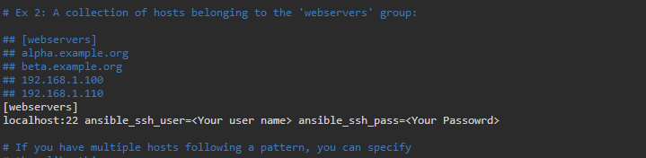

**Note**: Add the username and password of the lab you are using. You can access those using the RDP access tab.

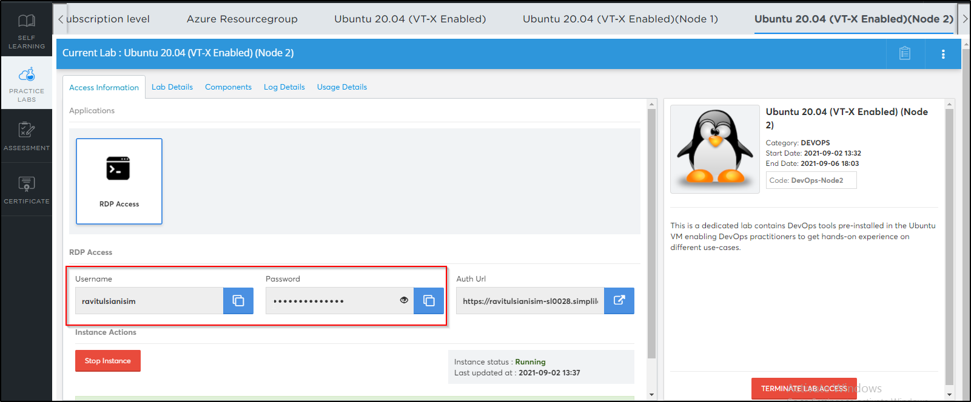

The reason to explicitly add username and password is that, in the main yaml file, the owner is mentioned as root. This requires a master user password to authenticate it. Once added in the format, just run ansible commands via the same provided user.

1. You can verify this by using the below commands:

***sudo su***

***nano /etc/sudoers***

1. Save and exit the file using **ctrl+x**

**Step 2: Creating Ansible Role**

1. Once we have our Ansible environment ready, next create a project directory

***mkdir project***

1. To create an ansible role, use ansible-galaxy init <role_name> to create the role directory structure

***cd project***

***mkdir roles***

***cd roles***

***ansible-galaxy init example***

1. You can use the ***ls*** command to list the ansible role directory structure

***cd example***

***ls***

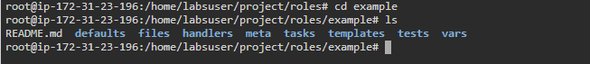

**Step 3: Creating Ansible Tasks**

1. Now update the /etc/example file using Ansible playbook roles. Create tasks to use the main.yml file present inside the tasks folder to copy a file from one location to another.

***cd tasks***

***ls***

***vi main.yml***



1. Enter the below code

*---*

***# tasks file for example***

***- name: copy example file***

***template:***

***src: templates/example.j2***

***dest: /etc/example***

***owner: root***

***group: root***

***mode: 0444***

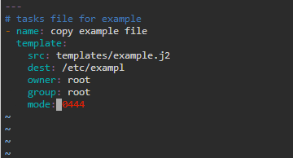

**Step 4: Creating an Ansible Template**

1. Create the template content which will be used to update /etc/example in our ansible roles examples. We will create a new template file under the template directory using some variables:

***cd ..***

***cd templates***

***vi example.j2***

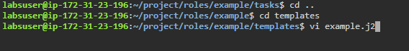

1. Enter the below details:

***Welcome to {{ ansible_hostname }}***

***This file was created on {{ ansible_date_time.date }}***

***Go away if you have no business being here***

***Contact {{ system_manager }} if anything is wrong***

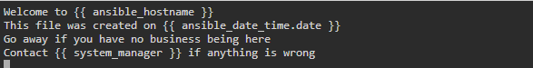

**Step 5: Creating Ansible Variable**

1. We will use the defaults folder to define custom variables which are used in our template file templates/example.j2

***cd ..***

***cd defaults***

***ls***

***vi main.yml***

1. Enter the below details in the file:

***---***

***# defaults file for example***

***system_manager:*** [***admin@golinuxcloud.com***](mailto:admin@golinuxcloud.com)

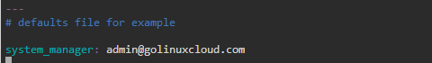

**Step 6: Removing unwanted directories (Optional)**

1. This step is optional. In this ansible roles example, we will not use other directories, so we are deleting them. After deleting the additional directories, you can use the tree command to list the directory structure of example roles

***cd ..***

***rm -rf handlers tests vars***

***ls***

**Step 7: Creating an ansible-role playbook**

1. Now, after you create an ansible role structure, we need a playbook file that will deploy the role to our managed hosts. I will create my playbook file example-role.yml under the base project directory

***cd ..***

***cd ..***

***sudo vi example-role.yml***

1. Enter the below code in the file

***---***

***- name: use demor role playbook***

***hosts: webservers***

***user: ansible***

***become: true***

***roles:***

***- role: example***

***system_manager:*** [***admin@golinuxcloud.com***](mailto:admin@golinuxcloud.com)

**Step 8: Installing sshpass package**

1. Execute the below command to install the sshpass package:

***sudo apt install sshpass***

**Step 9: Deploying the Ansible role playbook**

1. Execute the below command:

***ansible-playbook example-role.yml***

